**Functions**

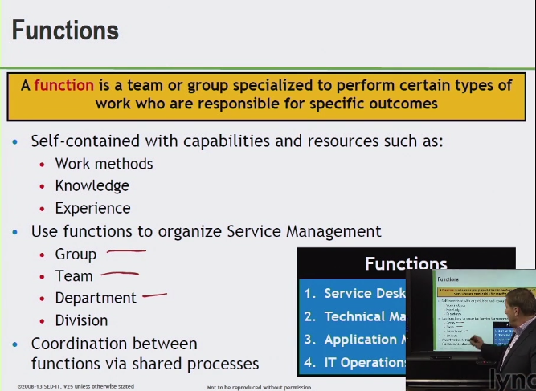

**4 types of IT function**

1. **Service Desk**

* **Central point of contact between IT, service providers, us, AND our users for operational type issues**

1. **Technical Management**

* **Provides the technical skills for ongoing operations of IT**

1. **IT Operations Management**

* **Day to day activities, the facilities management part of the functions**

1. **Application Management**

* **Coordination between functions via a shared process**

**Use functions to organize Service Management**

* **Group**

**Similar in some manner similar activities - technologies**

* **Team**

**Formal type of group – work to achieve a common objective**

* **Department**

**Formal organizational structure**

* **Division**

**Number of departments**

*Process flows through a functions

*Four functions must coordinate with each other in order for the organizational process to succeed throughout the life cycles of the processes

**Specific Roles**

Process Owner

Performs as documented

Process Manager

Process Pract.

Service Owner

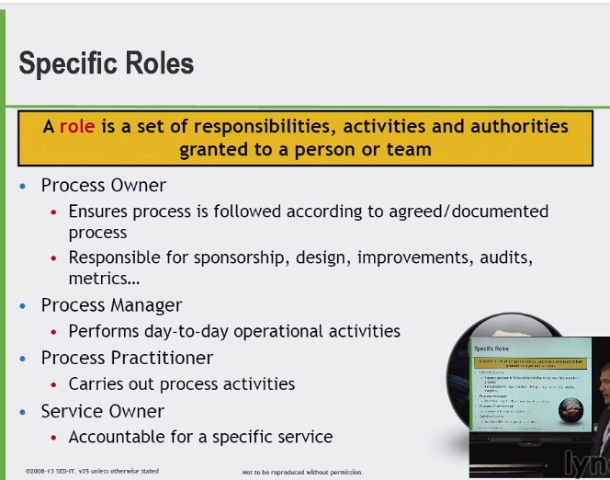

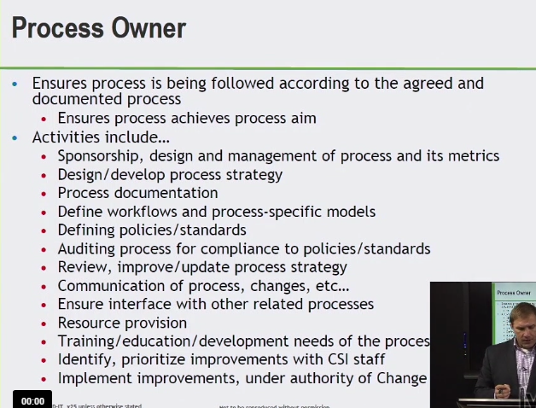

* Ensure process is followed according to the agreed and documented process

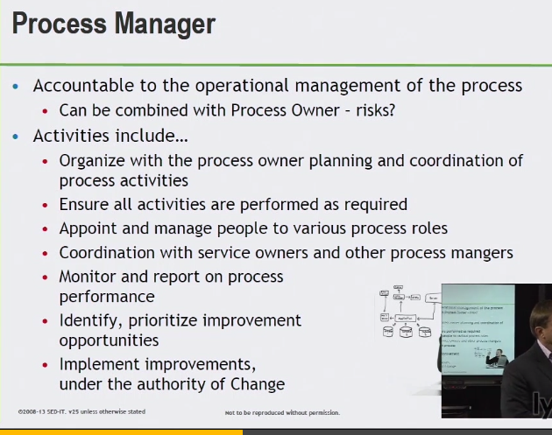

Operation management of the process

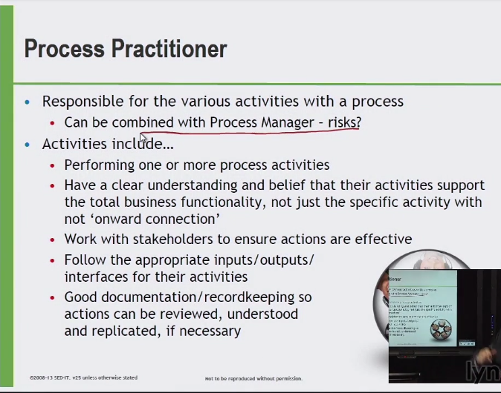

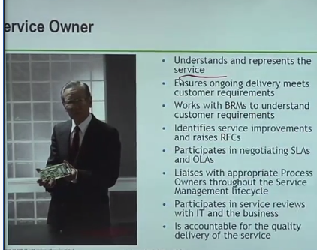

Represents the service

RFC (Request for change)

Service level agreement (SLA)

Operational level agreement (OLA)

**RACI Model / Authority Matrix**

Define roles within the service delivery

Process, activities within the process

Who is **responsible**, **accountable**, **consulted**, **informed** for certain pieces of this process

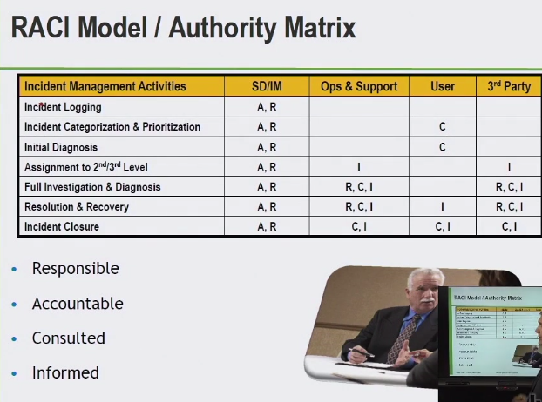

R

* The person or group responsible for actually getting job done

A

* The single individual accountable for the quality of the outcome

C

* The people who provide input the process activities

I

* Up to date on the progress of the activity

**RISK MANAGEMENT**

**Risk**

1. **ID**
2. **Analyze**
3. **Manage**

**Business Case**

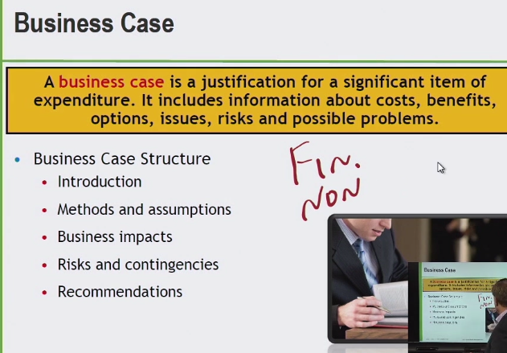

**Non-financial**

**Trust, integrity, etc.**

**Return investment**

1. **Business Objectives**
2. **Boundaries of the bus. Case – time & cost**
3. **Financial & non-financial bus. Case results**
4. **Probability – likelihood results will emerge**
5. **Specific actions recommended for business case**

**Communication**

(CSI – continuous service improvement)

What needs to be communicated and to whom? What do we want who does it go to? When? By which medium do we use?

Daily, email, chat? **Desired outcome of communication – purpose.**

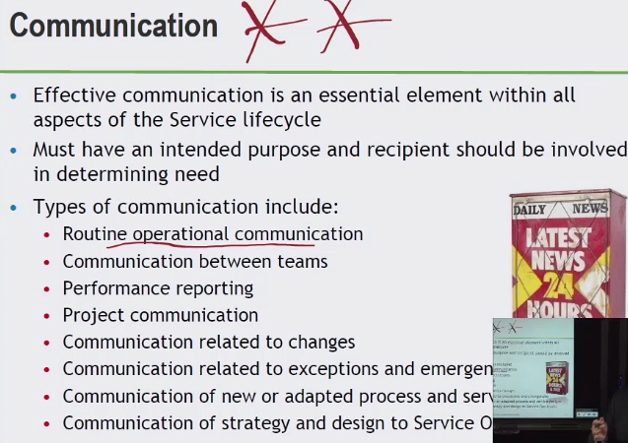

^Emergencies

^Service ops. Teams

**Service Portfolio, Pipeline & Catalog**

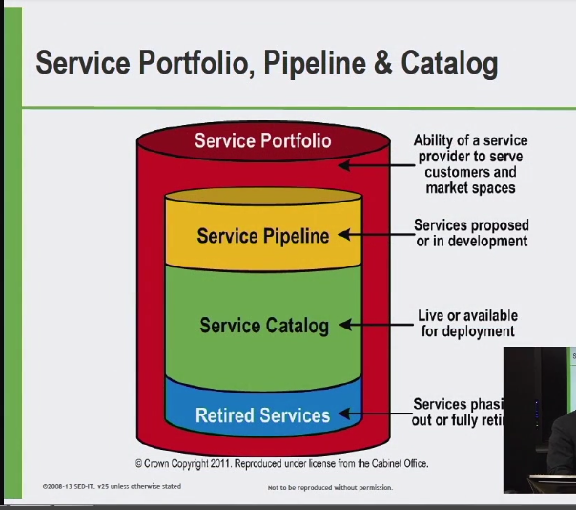

Integral parts – service management program

**Service Portfolio**

* Commitments in our investments into future, current and retired services that we provide for the customer
* Represents complete set of services
* Resources and finances etc.

**Service Pipeline**

* Future growth & strategic look

**Service Catalog**

* Active services that are visible today – present to customers

**Retired Services**

E.G. Script (service portfolio) (intent to be a movie strategic) – portfolio items – playing now live (service catalog) – when done playing it goes to DVD

Cycle for these services

**Prioritization**

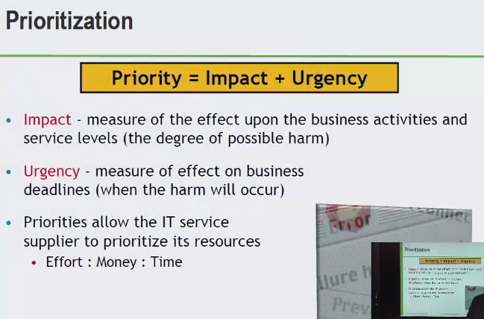

Priorty 1 p1 priorty 2 p2

Sev 1 sev 2

High medium low

How do we calculate this?

*Complex calculation* of urgency + impact

**Impact**

Direct effect of impact on a business

Financial lost, business reputation

**Urgency**

Deadlines – now factor?

Now means different things

Impact + Urgency = priortization

**Summary: Key principles, models, and concepts**

Process – measurable, results, customers, respond to an event or trigger

Process owners – documentation, policies, and procedures – process models

Function – unit of org. designed to do certain types of work

4 functions:

Service desk

Tech. mng

App. Mng.

IT mng.

Automation – well documented before you put the tool on

Prioritization = urgency + impact

Portfolio – *movie script* – views – not live services today

Key models and concepts

RACI – responsible, accountable, consulted and informed

Risk management – uncertainty, recognize risk and manage

Business case – justification for a significant item of expenditure

Communication

Process Owner – ensuring process performing as documented

Process mng. – Operationally run the process

Process Pract. – Performing those activities in the process

Service owner – liaison between IT service provider & customers as it relates to that service within service catalog that we have

Process Roles -